# Durable Furnitures

Noir

## New York Contemporary Sofa Table

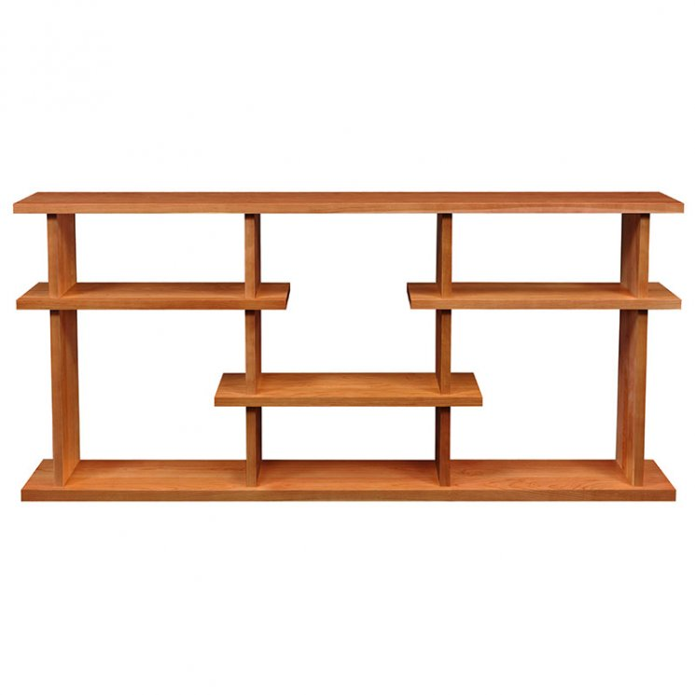

Our high end New York Contemporary Sofa Table features artistic flair with modern sensibilities. This unique piece provides a wonderful way to show off your treasures wherever you wish in style. It has a simple, modern design that will blend in perfectly in any contemporary or modern living room. Available in cherry, maple, oak and walnut hardwood. Choose a natural finish or select from our large variety of wood stains. This sofa table is made to order and built in Vermont using sustainably harvested woods.